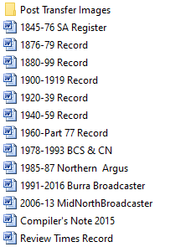

1845-76 SA Register 613

1876-79 Record 195

1880-99 Record 1,288

1900-1919 Record 1,247

1920-1939 Record 1,424

1940-1959 Record 1,502

1960- Part 77 Record 1,206

1978-1993 BCS & CN 407

1985-87 Northern Argus 73

1991-2016 Burra Broadcaster 762

2006-13 Mid North Broadcaster 371

Review Times Record 87

Total 9,168

500 sheets per ream = 18 reams